**CASCADING STYLE SHEETS**

CSS, or Cascading Style Sheets, is the language used to style and enhance HTML documents. It defines the presentation of HTML elements on a web page, enabling changes to fonts, colors, sizes, spacing, column layouts, and animations.

**Table of Content**

1. [Basic CSS Example](https://www.geeksforgeeks.org/css-tutorial/?ref=dhm#basic-css-example)
2. [CSS Tutorial](https://www.geeksforgeeks.org/css-tutorial/?ref=dhm#css-tutorial)
3. [CSS Fundamentals](https://www.geeksforgeeks.org/css-tutorial/?ref=dhm#css-fundamentals)
4. [CSS Styling Techniques](https://www.geeksforgeeks.org/css-tutorial/?ref=dhm#css-styling-techniques)
5. [CSS Responsive Design and Media Queries](https://www.geeksforgeeks.org/css-tutorial/?ref=dhm#css-responsive-design-and-media-queries)
6. [Advanced CSS Topics](https://www.geeksforgeeks.org/css-tutorial/?ref=dhm#advanced-css-topics)
7. [CSS Online Quizzes](https://www.geeksforgeeks.org/css-tutorial/?ref=dhm#css-online-quizzes)
8. [CSS Practical Projects](https://www.geeksforgeeks.org/css-tutorial/?ref=dhm#css-practical-projects)
9. [CSS Interview Preparation](https://www.geeksforgeeks.org/css-tutorial/?ref=dhm#css-interview-preparation)
10. [CSS Preprocessors](https://www.geeksforgeeks.org/css-tutorial/?ref=dhm#css-preprocessors)
11. [CSS Frameworks](https://www.geeksforgeeks.org/css-tutorial/?ref=dhm#css-frameworks)

**What is CSS?**

CSS, or **Cascading Style Sheets**, is a language used to style and enhance websites. It controls how **HTML elements**—such as *text*, *images*, and *buttons*—are displayed on a webpage. **With CSS**, you can adjust font sizes and colors, add backgrounds, and manage the layout, transforming a basic webpage into a visually appealing and user-friendly experience. CSS also simplifies **layout management** across multiple web pages by **using external stylesheets** stored in CSS files.

CSS (Cascading Style Sheets) is a language designed to simplify the process of making web pages presentable. It allows you to apply styles to HTML documents, describing how a webpage should look by prescribing colors, fonts, spacing, and positioning. CSS provides developers and designers with powerful control over the presentation of HTML elements.

HTML uses tags and CSS uses rulesets. CSS styles are applied to the HTML element using selectors. CSS is easy to learn and understand, but it provides powerful control over the presentation of an HTML document.

**Why CSS?**

* **Saves Time:**Write CSS once and reuse it across multiple HTML pages.
* **Easy Maintenance:** Change the style globally with a single modification.
* **Search Engine Friendly:** Clean coding technique that improves readability for search engines.
* **Superior Styles:** Offers a wider array of attributes compared to HTML.
* **Offline Browsing:**CSS can store web applications locally using offline cache, allowing offline viewing.

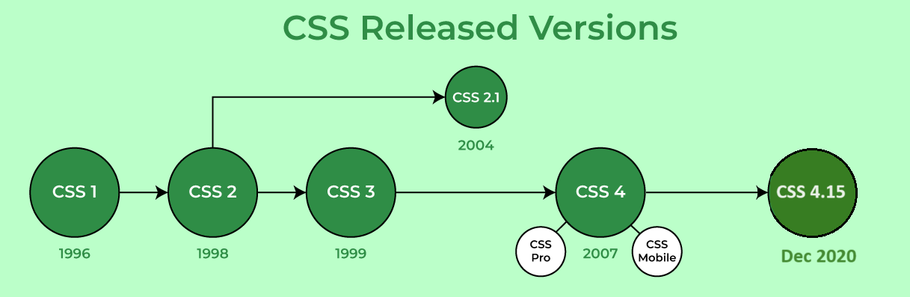

**CSS Syntax**

CSS consists of style rules that are interpreted by the browser and applied to the corresponding elements. A style rule set includes a selector and a declaration block.

* **Selector:** Targets specific HTML elements to apply styles.
* **Declaration:** Combination of a property and its corresponding value.

// HTML Element

<h1>GeeksforGeeks</h2>

// CSS Style

h1 { color: blue; font-size: 12px; }

**Where -**

Selector - h1

Declaration - { color: blue; font-size: 12px; }

* The **selector points** to the HTML element that you want to style.
* The **declaration block** contains one or more declarations separated by semicolons.
* Each **declaration** includes a CSS property name and a value, separated by a colon.

p {

color: blue;

text-align: center;

}

CSS **declaration always ends with a semicolon**, and declaration blocks are surrounded by **curly braces**. In above example, all paragraph element (<p> tag) will be centre-aligned, with a blue text color.

**Web Page with & without CSS**

**Without CSS:** In this example, we have not added any CSS style.

<!DOCTYPE html>

<html>

<head>

<title>Simple Web Page</title>

</head>

<body>

<main>

<h1>HTML Page</h1>

<p>This is a basic web page.</p>

</main>

</body>

</html>

**OUTPUT:**

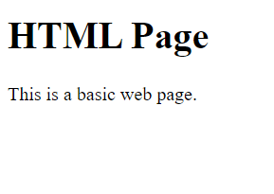

**Using CSS:** In this example, we will add some CSS styles inside the HTML document to show how CSS makes a HTML page attractive and user-friendly.

<!DOCTYPE html>

<html>

<head>

<title>Simple web page</title>

<style>

main {

width: 600px;

height: 200px;

padding: 10px;

background: beige;

}

h1 {

color: olivedrab;

border-bottom: 1px dotted darkgreen;

}

p {

font-family: sans-serif;

color: orange;

}

</style>

</head>

<body>

<main>

<h1>My first Page</h1>

<p>This is a basic web page.</p>

</main>

</body>

</html>

**OUTPUT:**

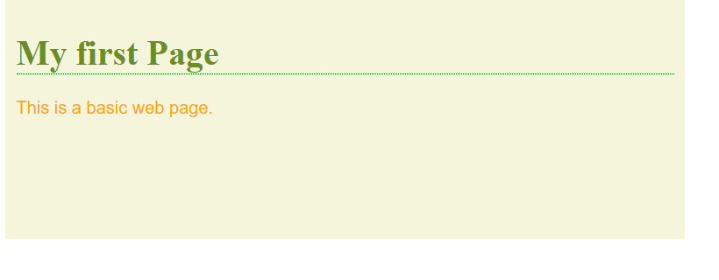

CSS is essential for creating visually appealing and maintainable web pages. It enhances the website look and feel and user experience by allowing precise control over the presentation of HTML elements.

**CSS Syntax**

A **CSS Syntax** rule consists of a selector, property, and its value. The selector points to the HTML element where the CSS style is to be applied. The CSS property is separated by semicolons. It is a combination of the selector name followed by the **property: value** pair that is defined for the specific selector. let us see the syntax and how we can use the CSS to modernize the website.

**Syntax:**

selector { Property: value; }

For instance, we have declared a heading tag (h1) along with having assigned some ***property: value*** pair that is used to style the heading tag. Here, ***h1***is the selector,***{ color: green; font-family: sans-serif; }***is a declaration block and it can contain one or more declarations separated by semicolons,***color: green;***is a *property: value* pair that is applied to the HTML element to style them.

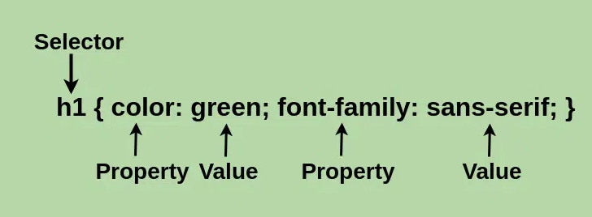

Every declaration has a CSS property name and a value, separated by a **colon(:)** and is surrounded by **curly braces({ })**. For declaring the multiple CSS properties, it can be separated by the **semicolon(;)**.

Let’s define each of these:

* **Declaration:**A combination of a property and its corresponding value.
* **Selector:**Used to target and select specific HTML elements to apply styles to.
* **Property:** Defines the specific aspect or characteristic of an element that you want to modify.
* **Value:** Assigned setting or parameter for a given property, determining how the selected element should appear or behave.

**Different Ways to Use CSS**

CSS has three ways to style the HTML:

* **Inline**: Add styles directly to HTML elements using the style attribute (limited use).
* **Internal**: Place styles within a *<style>* tag inside the HTML file, usually within the *<head>* section
* **External**: Create a separate CSS file with a *.css* extension and link it to your HTML file using the*<link>* tag.

**Advantages of CSS:**

* CSS you simply got to specify a repeated style for element once & use it multiple times as because CSS will automatically apply the required styles.
* CSS style is applied consistently across variety of sites. One instruction can control several areas which is advantageous.
* Web designers need to use few lines of programming for every page improving site speed.
* CSS simplifies both website development and maintenance as a change of one line of code affects the whole web site and maintenance time.
* It is less complex therefore the effort is significantly reduced.
* It helps to form spontaneous and consistent changes.
* CSS changes are device friendly. With people employing a batch of various range of smart devices to access websites over the web, there’s a requirement for responsive web design.
* It has the power for re-positioning. It helps us to determine the changes within the position of web elements who are there on the page.
* These bandwidth savings are substantial figures of insignificant tags that are indistinct from a mess of pages.
* Easy for the user to customize the online page
* It reduces the file transfer size.

**Disadvantages of CSS:**

* CSS, CSS 1 up to CSS3, result in creating of confusion among web browsers.
* With CSS, what works with one browser might not always work with another. The web developers need to test for compatibility, running the program across multiple browsers.
* There exists a scarcity of security.
* After making the changes we need to confirm the compatibility if they appear. The similar change effects on all the browsers.
* Browser compatibility (some styles sheet are supported and some are not).
* CSS works differently on different browsers. IE and Opera supports CSS as different logic.
* There might be cross-browser issues while using CSS.
* There are multiple levels which creates confusion for non-developers and beginners.

**Basic CSS Example**

Below example shows inline, internal, and external style sheet with different properties.

<!-- File name: **index.html** -->

<!DOCTYPE html>

<html lang="en">

<head>

    <meta charset="UTF-8">

    <meta name="viewport" content="width=device-width, initial-scale=1.0">

**<!-- Importing External CSS -->**

**<link rel="stylesheet" href="style.css" />**

**<!-- Using Internal CSS -->**

**<style>**

**h2 {**

**color: green;**

**background-color: orange;**

**}**

**</style>**

    <title>Inline Internal and External CSS Demo</title>

</head>

<body>

        <!-- Using Inline CSS -->

        <h2 style="text-align: center;">Welcome To CSS</h2>

        <p>CSS Tutorial</p>

</body>

</html>

/* External CSS */

/* File name: **style.css** */

p {

    text-align: center;

    color: chartreuse;

    font-size: 33px;

  }

**OUTPUT:**

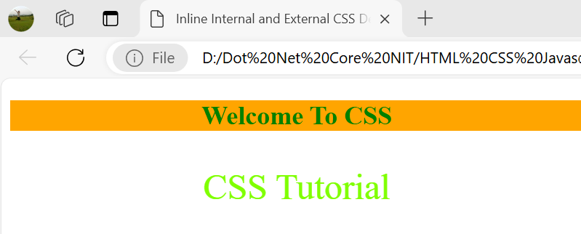

* **FAQs:**

1. **What is CSS?**

*CSS (Cascading Style Sheets) is a language for styling HTML or XML documents, controlling layout, colors, fonts, and overall appearance to enhance user experience.*

1. **Why is CSS important?**

*CSS separates content from design, improves accessibility, enhances user experience, and provides responsive designs for different devices and screen sizes.*

1. **How do you add CSS to a web page?**

* *Inline CSS: Using style attribute within HTML.*
* *Internal CSS: Using <style> block in <head>.*
* *External CSS: Linking a CSS file with <link> tag.*

1. **What is the syntax of CSS?**

*CSS syntax: selector { property: value; }. Selectors target elements; properties define style attributes; values specify styling details.*

1. **What are CSS selectors?**

*CSS selectors target elements for styling. Common types: element, class, ID, and attribute selectors.*

1. **What are CSS properties?**

*CSS properties define styles like color, font-size, margin, and padding. Example: p { color: blue; }.*

Other Topics:

CSS Pseudo Class

Nesting of CSS code

@layer Directive

@container